Lemongrass Oil – India’s Fragrant Green Gold for Global Wellness & Industry | The Export Express


Introduction
Lemongrass oil, extracted from Cymbopogon flexuosus, is one of India’s most valuable essential oils — widely recognized for its lemony, herbaceous aroma and high citral content. Known in global markets as “Green Gold,” this versatile oil bridges the gap between industrial applications and natural wellness, making it an indispensable product for aromatherapy, pharmaceuticals, perfumery, and personal care.
At The Export Express, we specialize in supplying 100% pure, steam-distilled Indian lemongrass oil to international buyers seeking consistency, traceability, and superior aroma retention. With a strong reputation for quality and sustainability, we help brands and manufacturers worldwide source premium-grade lemongrass oil directly from India’s finest distillation units.

Botanical & Technical Overview
Parameter | Specification
Botanical Name | Cymbopogon flexuosus
Common Name | Lemongrass Oil
Family | Poaceae (Gramineae)
Extraction Method | Steam or Hydro-distillation
Main Constituents | Citral (70–77%), Myrcene, Geraniol, Nerol
Refractive Index (20°C) | 1.480 – 1.490
Specific Gravity (20°C) | 0.890 – 0.920
Optical Rotation | -5° to +2°
Solubility | Soluble in alcohol and organic solvents; insoluble in water
Color | Light to Pale Yellow
Odor | Strong, sharp, and fresh lemony-grassy aroma
Shelf Life | 24 Months under cool, dry conditions
Lemongrass oil is derived from the tall, perennial Cymbopogon grass that thrives in tropical Indian climates, particularly in Karnataka, Kerala, Tamil Nadu, and West Bengal. The oil is obtained by distilling freshly cut leaves and stems, capturing its characteristic citral-rich aroma that serves as a natural base for lemon-scented formulations.

Extraction Process

The primary extraction method used by The Export Express is steam distillation, ensuring the oil remains pure, natural, and true to its botanical origin.
- Harvesting: Mature lemongrass is hand-cut at 60–90 cm height.
- Chopping & Loading: Leaves are chopped and loaded into stainless steel distillation chambers.
- Steam Distillation: Steam passes through the biomass, releasing volatile aromatic compounds.
- Condensation: Vapors are condensed and separated from water in collection receivers.
- Filtration & Storage: The crude oil is filtered, quality-tested, and stored in airtight containers.
This method preserves the oil’s citral concentration while minimizing oxidative degradation — ensuring longer shelf life and greater aromatic stability for export.

Chemical Composition & Citral Content
The citral content (a mix of geranial and neral) defines the purity and quality of lemongrass oil. Indian lemongrass oil supplied by The Export Express typically contains 70–77% citral, meeting international standards for perfumery and pharmaceutical applications.
Other key constituents include:
- Myrcene (10–12%) – contributes to the herbaceous aroma
- Geraniol (2–5%) – enhances floral undertones
- Nerol (1–3%) – adds sweetness and stability
- Limonene, Linalool, and Caryophyllene – secondary aroma compounds enhancing versatility

Applications Across Industries

1. Perfumery & Cosmetics
Lemongrass oil is a cost-effective natural source of citral, widely used in perfumery as a base note or blending component.
- Adds a fresh, lemony top note in soaps, lotions, and perfumes
- Used in deodorants, hair cleansers, and body sprays
- Excellent natural masking agent in formulations

2. Pharmaceuticals & Therapeutics
The oil exhibits antiseptic, antifungal, and anti-inflammatory properties, making it suitable for topical ointments and oral care formulations.
- Used in Vitamin-A synthesis, balms, and herbal ointments
- Effective against microbial infections and skin inflammation
- Commonly used in aromatherapy for stress reduction and mental clarity

3. Aromatherapy & Home Care
Consumers prefer lemongrass essential oil for its refreshing scent and cleansing properties. It’s often diffused to purify indoor air and repel insects naturally.
- Acts as a natural deodorizer and mood enhancer
- Ingredient in candles, diffusers, and room sprays
- Used with carrier oils for massage therapy and relaxation


4. Industrial Applications
- Raw material for citral production used in flavoring and fragrance intermediates
- Ingredient in insect repellents and disinfectants
- Utilized in textile and leather industries for scenting treatments

Comparative Analysis – Lemongrass Oil by Origin
Parameter | Indian Lemongrass Oil (The Export Express) | Sri Lankan Lemongrass Oil | Thai Lemongrass Oil
Citral Content | 70–77% | 65–70% | 68–72%
Aroma Profile | Sharp, herbaceous, and clean | Milder, slightly woody | Sweet and lemony
Color | Pale yellow | Yellowish-green | Light yellow
Yield Efficiency | High (0.4–0.5%) | Medium | Medium
Export Grade Stability | Excellent | Good | Moderate
Industrial Demand | Global leader | Regional markets | Niche aromatherapy
Applications | Perfumery, Pharma, Aroma Diffusers | Cosmetics, Massage Oils | Fragrance, Spa Oils
Indian lemongrass oil dominates international trade due to its high citral concentration, yield efficiency, and consistent export quality — qualities assured by The Export Express.

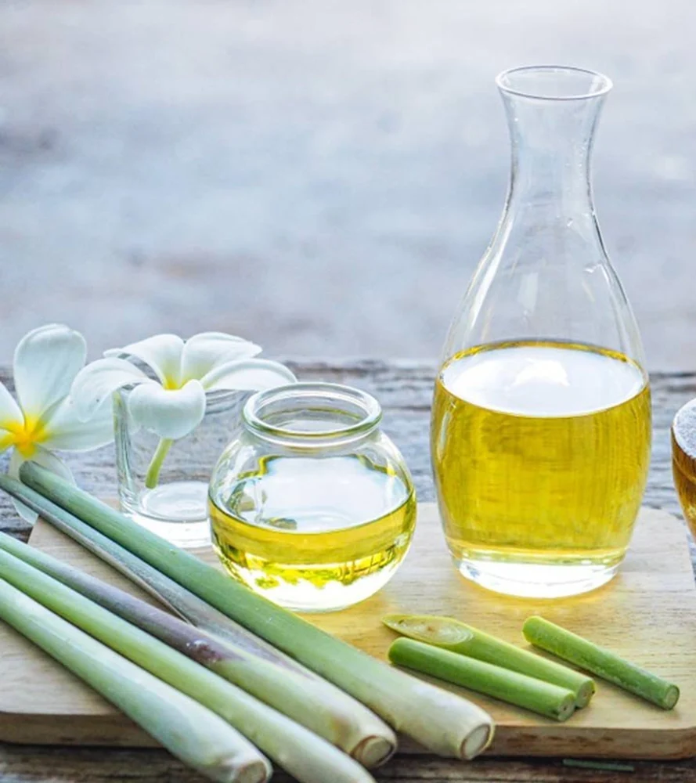
Health, Therapeutic & Consumer Benefits

- Natural Detoxifier: Supports healthy digestion and detoxification.
- Anti-inflammatory Agent: Reduces joint pain and inflammation.
- Antibacterial Properties: Inhibits bacterial growth and skin infections.
- Stress Relief: Promotes calmness when used in diffusers or bath oils.
- Skin Health: Helps treat acne, oily skin, and eczema when diluted.
- Insect Repellent: Citral acts as a natural mosquito deterrent.
For consumers and product manufacturers alike, lemongrass oil delivers functional value with a pleasant natural scent, making it a dual-purpose ingredient for both health and fragrance.

Regulatory Standards & Quality Compliance
To meet international export requirements, The Export Express ensures every batch of lemongrass oil complies with global standards:
- ✅ FSSAI Certified – Purity and safety for food & cosmetic-grade use
- ✅ ISO 9235:2013 – Conformance for natural aromatic raw materials
- ✅ IFRA-Compliant – Safe for perfumery and skincare applications
- ✅ GMP & MSDS Certified – Quality, safety, and handling documentation for export
- ✅ Pharmacopoeia Grade – Meets standard specifications for therapeutic use
Each export consignment undergoes GC-MS testing, verifying citral composition and absence of adulterants — ensuring authenticity and long-term reliability for global buyers.

Packaging & Export Solutions
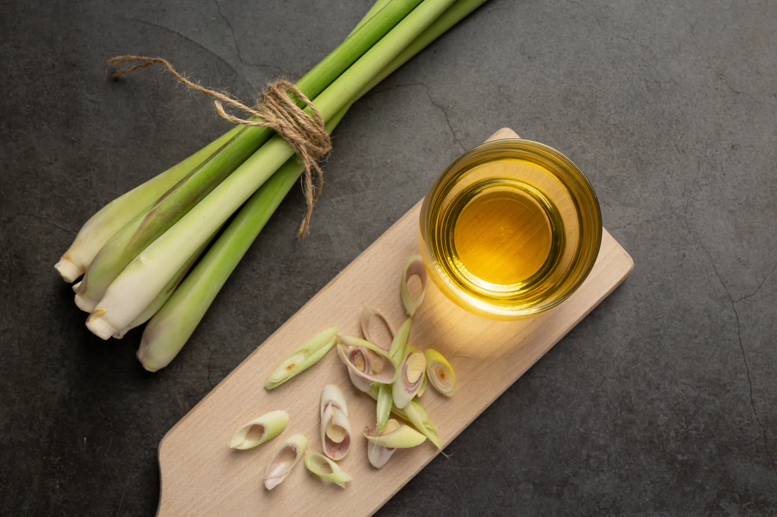
The Export Express offers customizable packaging to suit industrial, retail, and wholesale clients.
Available sizes: 1 kg, 5 kg, 10 kg, 25 kg, 50 kg, and 180 kg HDPE drums or aluminum containers.
Packaging Highlights:
- Leak-proof, food-grade HDPE & GI drums
- Light-protective aluminum bottles for retail formats
- Private labeling & OEM options for international distributors
- Export documentation: COA, MSDS, FSSAI, and Phytosanitary Certificates
Our supply chain ensures timely global delivery through major logistics partners and port connections, catering to buyers across Europe, the Middle East, North America, and East Asia.

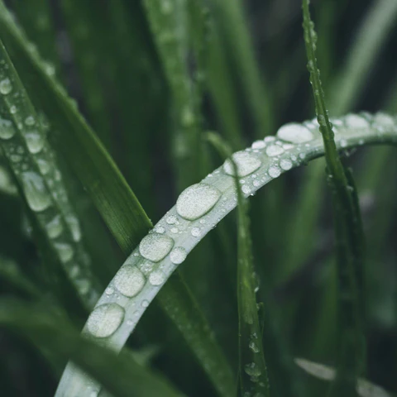
Sustainability & Responsible Sourcing
The Export Express partners with smallholder farmers and distillers across India who practice eco-conscious farming and chemical-free distillation.
- Lemongrass cultivation uses minimal water and restores soil fertility.
- By-product biomass is recycled as natural compost.
- Each lot is traceable from field to container, ensuring full transparency.
This commitment to sustainability allows us to offer products that are ethically sourced, environmentally responsible, and fully compliant with international import norms.

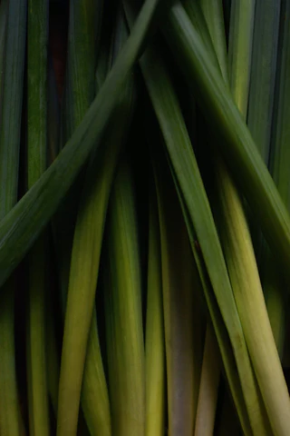
Why Choose The Export Express for Lemongrass Oil
- 100% Pure, Steam-Distilled Oil with verified citral composition
- Certified by FSSAI, ISO, and IFRA for export-grade use
- Consistent quality and aroma retention across batches
- Custom packaging for bulk buyers and OEM brands
- Transparent sourcing and global logistics network
Whether you are an aromatherapy brand, cosmetic manufacturer, or industrial fragrance house, The Export Express ensures unmatched purity, traceability, and reliability.

Contact & Bulk Order Enquiries
For technical specifications, safety data sheets, or private labeling options, connect with our export team today.
📦 Bulk Orders: Available in 1–180 kg drums
Partner with The Export Express to source authentic Indian lemongrass oil – sustainably distilled, globally compliant, and technically superior.

